#### Submitted By: M. Talha Atif F2021266573

#### Quiz 3 as assignment

# Code:

<!-- Name: M.Talha Atif -->

 <!-- ID: F2021266573 -->

<!DOCTYPE html>

<html lang="en">

<head>

    <title>talha atif quiz number 3</title>

    <style>

        button{

            background-color: #9be0c7;

            border-radius: 10px solid yellow;

            border-top-right-radius: 10px;

            margin: 40px;

            padding: 20px;

        }

    </style>

</head>

<!--  my body of dom document  (dom is my heirarchy of elements given through tags , root is html then so on child nodes are body and head) -->

<body>

    <!-- Button for checking number given is odd or even -->

    <button onclick="checkEvenOdd()"> Even-Odd</button>

    <!-- This div will be used to display result for even and odd number -->

    <div id="resultEvenOdd">  </div>

    <!-- Button for printing array in reverse order -->

    <button onclick="reverseArray([1,2,3,4,'talha atif','checking test post get'])"> Reverse the array </button>

    <!-- This div will be used to display result for reverse of array -->

    <div id="reverseArray"> </div>

    <!-- Button for getting index of element in array-->

    <button onclick="useGetIndex()"> Get element index </button>

    <!-- This div will be used to display result for displaying index of fetched element  -->

    <div id="getIndex"> </div>

     <!-- Button for getting index of element in array-->

     <button onclick="takeColor()"> Set Background Color </button>

     <!-- This div will be used to display result for displaying index of fetched element  -->

     <div id="takeColor"> </div>

    <!-- Javascript code is here below -->

    <script>

    //  This function will check number taken from windows prompt

    // Using if number will be divided by 2, if remainder is zero than result is even

    // Else result will be odd

    // 2%2 == 0 is so it is even

    // 3%2 == 2 so it is odd

        function checkEvenOdd(){

            //  taking input

            let number = parseInt(  prompt('Enter a number: '))

            // checking using if condition

            // even case

            if (number%2==0){

                document.getElementById("resultEvenOdd").innerHTML=  "Hey!, you entered " + number + " -> is even (:"

            }

            // odd case

            else{

                document.getElementById("resultEvenOdd").innerHTML=  "Hey!, you entered " + number + " -> is odd ):"

            }

        }

        // Question 2

        // function to print elements in reverse order of the array

        function reverseArray(myArray){

            //  this line will add string in div reverse array

            document.getElementById("reverseArray").innerHTML = "Hey Reverse of your given array: -> "

            // iterate from end of array index and then go upward towards 0 like array size is 5, then 4 to 0 by

            // decrementing --, -- here is postfix operator with --

            for( i = myArray.length-1; i>=0 ; i--){

                console.log( myArray[i])

                // using ' ', we added space and using += we concatenated so that previous element not lost

                document.getElementById("reverseArray").innerHTML +=  myArray[i] + ' '

            }

        }

        // Question 3

        // function that takes number as input and give index, for doing that we can pass array as well

        // to function or may be we can create inside function

        function getIndex(myArray, element){

            //  this line will add string in div reverse array

            // iterate from starting index 0 to end index that is length of array - 1

            index = -1

            for( i = 0; i < myArray.length - 1 ; i++){

                if (element == myArray[i]){

                 index = i

                 break; // here breaking because may be there are duplicate values in our array being passed

                }

            } // end of for loop

            return index // it will give -1 if element is not in array

        }

        // Use above function to get index of array

        function useGetIndex(){

            myArray = new Array(10)

            // hard code assignment

            myArray[0] = 'talha'

            myArray[1] = 'how are you'

            myArray[2] = 'how are you too'

            myArray[3] = 4

            // 30,31,32,33,34,35,36 will be values stored using below loop (assigning using loop)

            // i've used m as index for iteration and i as value for assignment

            m = 0

            for (i = 30, m=4; i <37; i++,m++){

                myArray[m] = i

            }

            console.log(myArray)

            let element = prompt('Hey enter element to find: ')

            // get index of element

            let obtainedIndex = getIndex(myArray, element)

            if( obtainedIndex  != -1){ // -1 means that element is not there, and not -1 mean element is there

              document.getElementById("getIndex").innerHTML = "Hey Index for given element " + element + "is : -> " + obtainedIndex

            }

            else{

                document.getElementById("getIndex").innerHTML = 'OOps! your element is not in that array'

            }

        }

        // Question 4

        // Taking color from user or setting it as bacground color

        function takeColor(){

           color =  prompt('Hey! please enter a color or you can type hex code without hash sign (should be 6 letters for hex code)')

           if (color.length <=1 ){

                document.getElementById("takeColor").innerHTML = 'Color Length should be greater than 1 for giving hex code or name'

           }

           hexCode = false

           for( i=0; i< color.length -1 ; i++){

               if (color[i]>='0' && color[i]<='9'){

                hexCode = true

               }

           }

           if(hexCode){ // by hexa code

            document.body.style.backgroundColor = '#' + color

            document.getElementById("takeColor").innerHTML = 'Color given using hexacode: -> #' + color

           }

           else{ // by name

            document.body.style.backgroundColor = color

            document.getElementById("takeColor").innerHTML = 'Color given using name: -> ' + color

           }

        }

        // end of script tag

    </script>

    <!-- End of html body tag -->

</body>

</html>

# Output:

## Initial Page

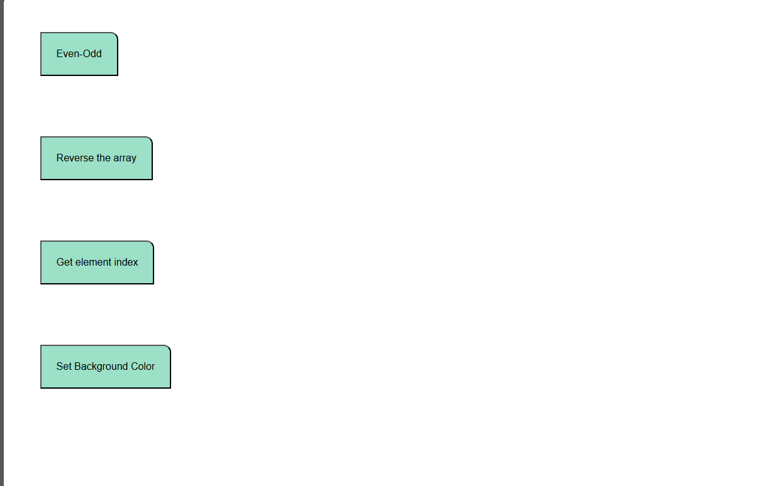

## Even Odd function working

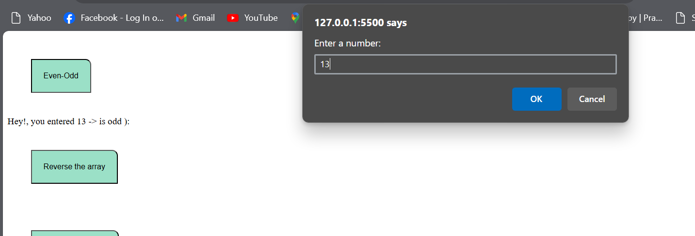

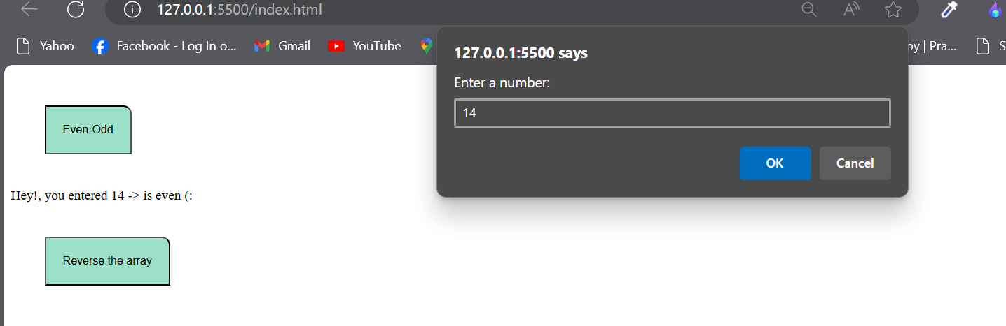

## Reverse Array function working



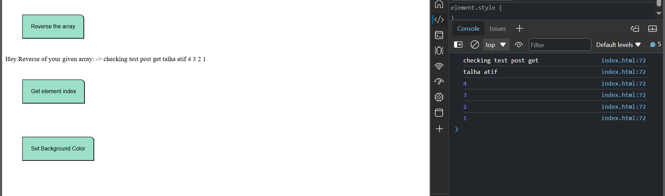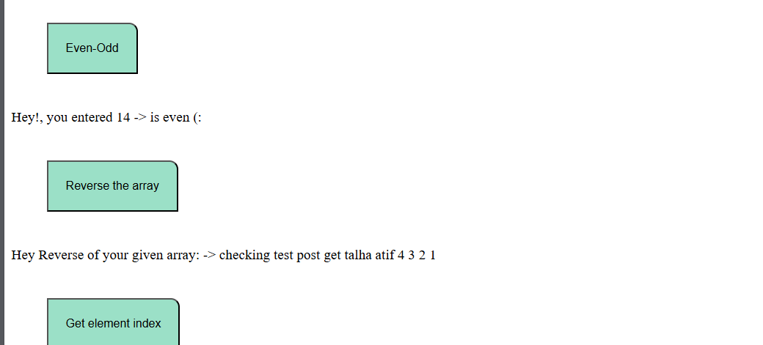

## Element Index Function working

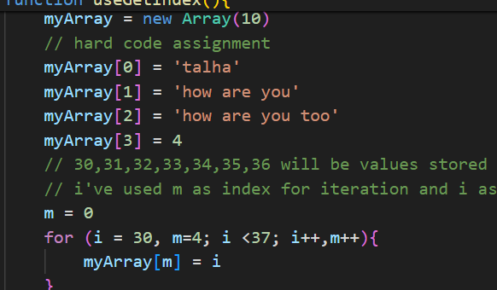

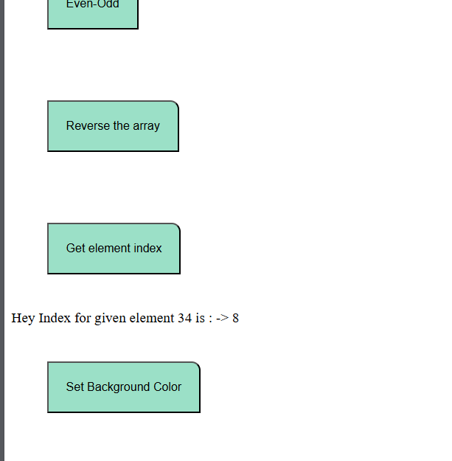

**34 is given as element and its index returned to me is 8.**

## Function Set Background Color working

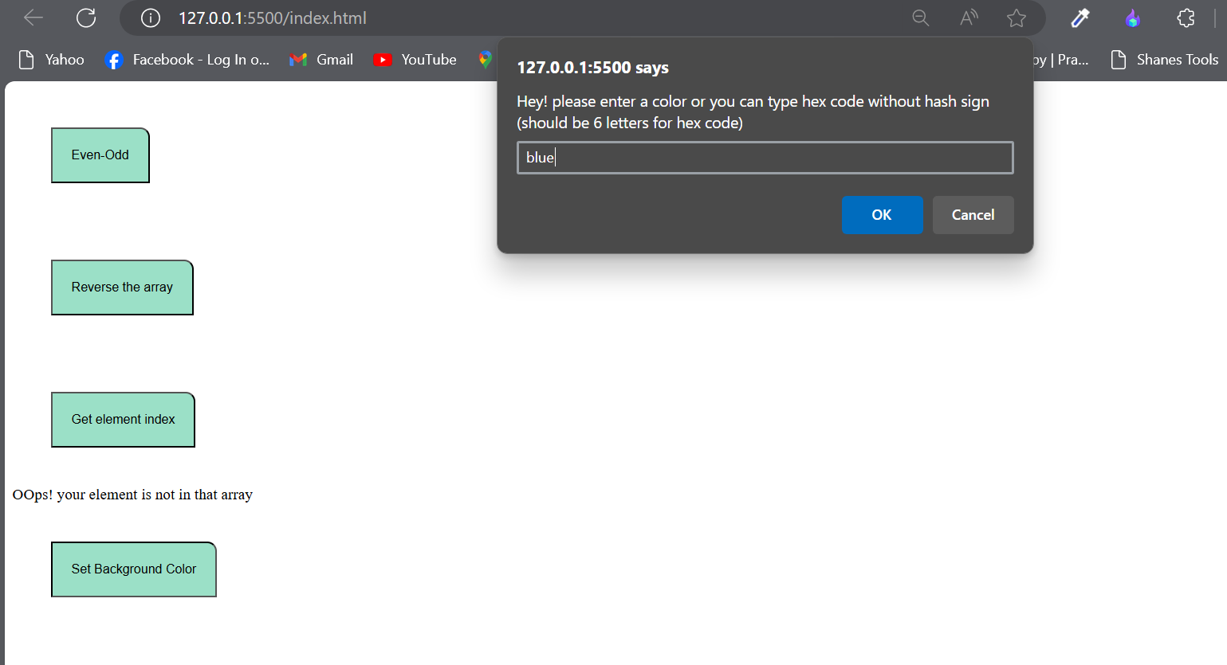

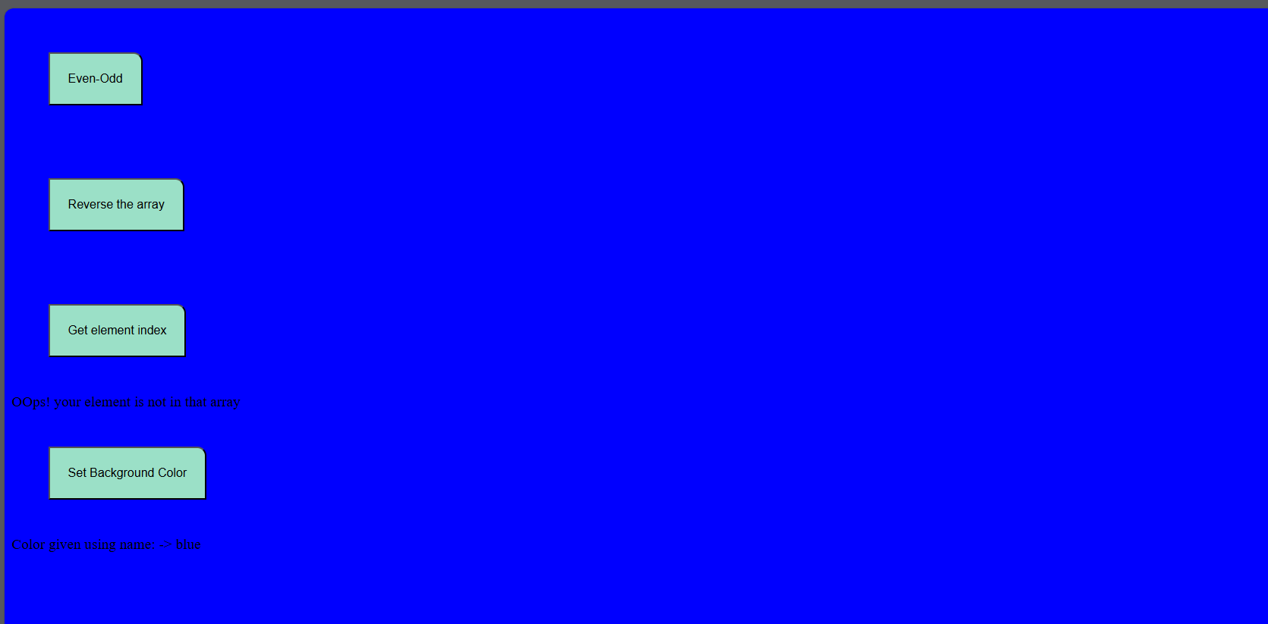

**Now again setting white color,**

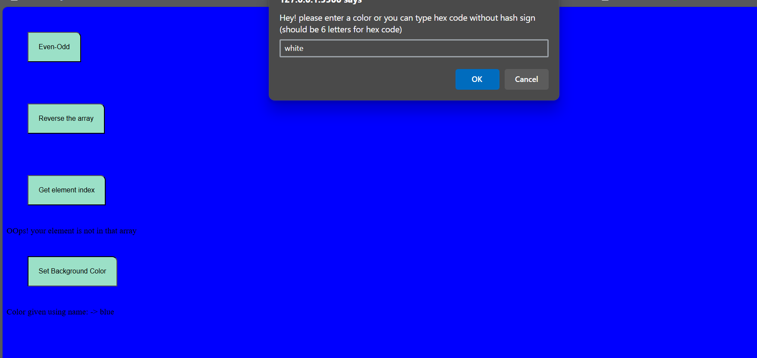

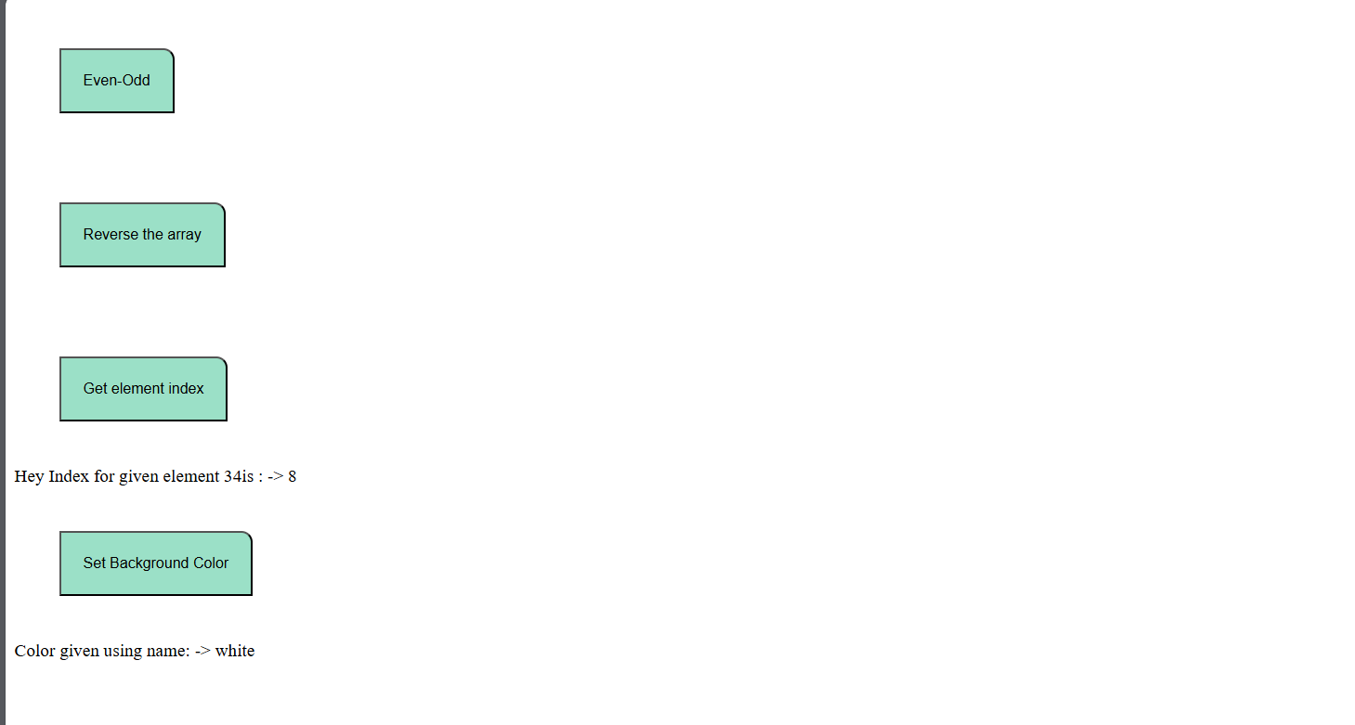

**Using hex code:**

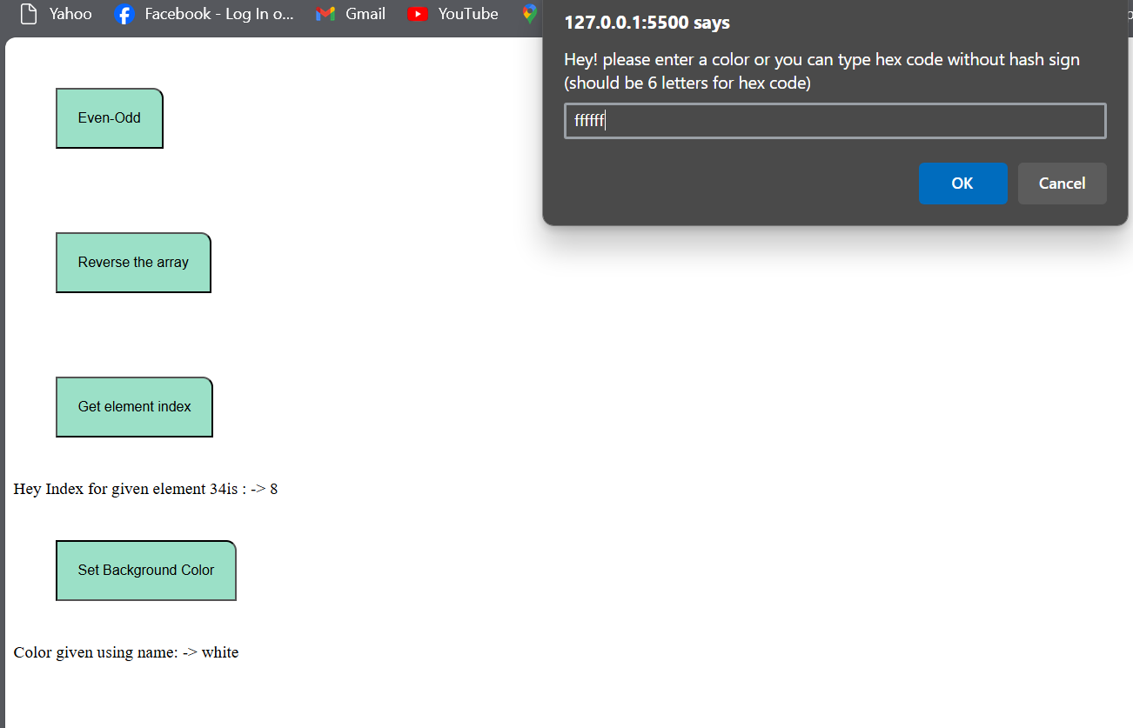

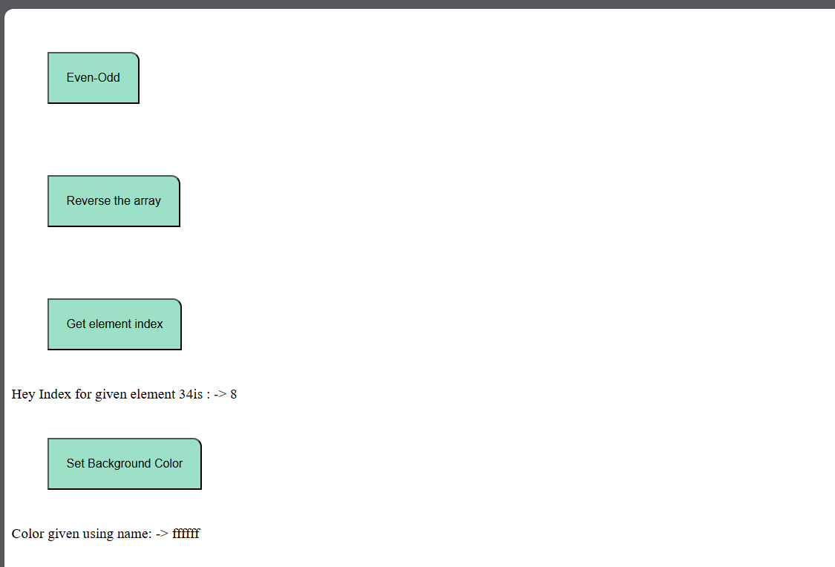

**3b3b3b as input**

